Alteration of Gateway Determination

Planning proposal (Department Ref: IRF20/3759) [PP_2018_LPOOL_001_03]

I, Director Western, Central River City and Western Parkland City at the Department of Planning, Industry and Environment, as delegate of the Minister for Planning and Public Spaces, have determined under section 3.34(7) of the Environmental Planning and Assessment Act 1979 to alter the Gateway determination dated 23 January 2018 (since altered) for the proposed amendment to the Liverpool Local Environmental Plan 2008 as follows:

- Delete condition 4 and replace with a new condition 4:

“The time frame for completing the LEP is by 22 January 2021.”

Dated 11th day of August 2020.
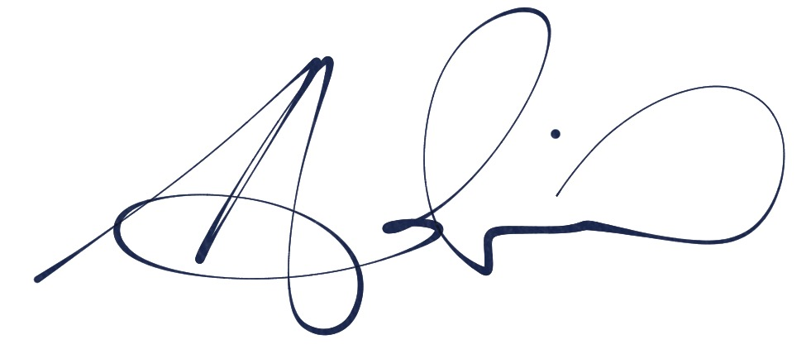

Adrian Hohenzollern
Director Western
Central River City and Western Parkland City
Department of Planning, Industry and Environment

Delegate of the Minister for Planning and Public Spaces

